Rights vs. Responsibilities
Rights Responsibilities
- Freedom of speech - Serving on juries
- Freedom of religion - Obeying laws
- Freedom of press - Tolerating differences in people around us
- Protection under the law - Participating in our government
- Access to the judicial system - Voting

Requirements to vote in Texas
- Be a United States citizen
- Not totally mentally incapacitated
- Must be 18 years old on election day
- Cannot be a convicted felon (unless time served)
- Be a resident of a Texas county

Republicans & Democrats
- In the US we have a 2-party system as 2 major parties dominate elections
  - Republicans: conservative, right, elephant is the symbol, color is red
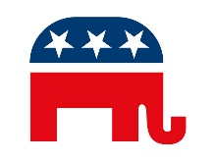
  - Democrats: liberal, left, donkey is the symbol, color is blue
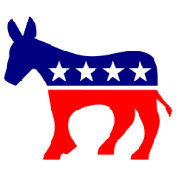

“Motor-Voter” Bill
- A bill passed by Congress in 1993 that let’s US citizens register to vote when they apply for a drivers license.

Campaign
- An organized effort in which people try to influence the decision-making process within a particular group
  - Example: Obama and Romney were conducting campaigns for the presidency.

