Name:
Period:
NAFTA- North American Free Trade Agreement Analysis
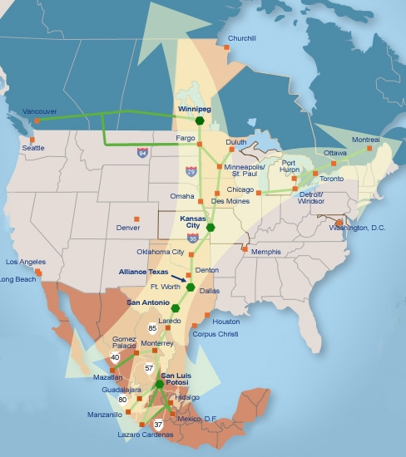
1. Which cities on this map appear to be the main “hubs” or connecting points along the super highway? How do you know this?

2. Name five other main cities shown on the map. Some of these cities are not located on the super highway. Why do you think these cities are shown at all?

3. NAFTA is an example of cooperation and good will between democratic countries. However, some Americans believe that NAFTA is not good for America. Pretend for a minute that you are an avocado farmer in Mexico. How could this trade agreement be good for your business?

Now pretend that you are an avocado farmer in California. How could this trade agreement be bad for your business?

Pose a Solution:
4. What could you do to help the California farmers and still allow the Mexican farmers to sell their avocados (without ending the trade agreement)?

