1/27/15 Notes
- Demand: is the desire to own something and the ability to pay for it
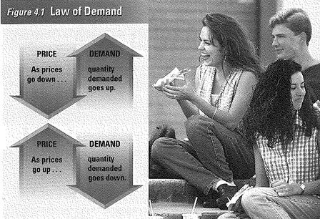
- Law of Demand: consumers buy more of a good when the price goes down, and buy less of a good when the price goes up

- Substitute Effect: when consumers react to an increase of one good, they buy less of more of the other goods
- Income Effect: buying changes when there is a change in real income
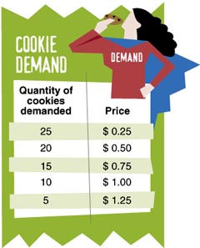
- Demand Schedule: (talking about one person) a table that lists the amount of a good that a person will buy at different prices

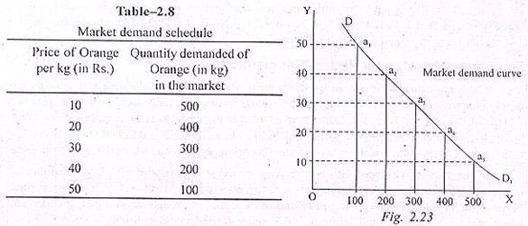
- Market demand schedule: table that shows the quantity of a good demanded at each price by all buyers

- Demand curve: a graph that shows a demand schedule
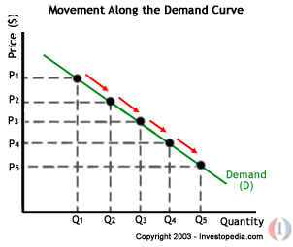

- Ceteris Paribus: Latin phrase that means “all other things held constant”
- Normal good: a good that consumers demand more of when their income goes up (increase demand)
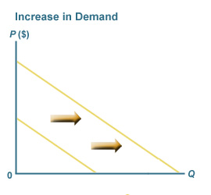

- Inferior good: a good that consumers demand less of when their income goes up (decrease demand)
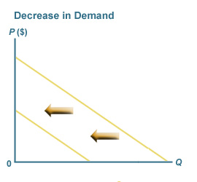

- Elasticity of demand: a measure of how consumers react to a change in price (happens right away)
Percentage change in quantity demand
  - Elasticity = Percentage change in price

- Inelastic: describes demand that is not affected to change in price
- Elastic: describes demand that is affected to change in price
- Unitary elastic: describes demand that has a elasticity exactly equal to 1
- Total revenue: total amount of money a firm receives by selling goods or services
- Revenue Table: (see table below)

Price of a slice of Pizza | Quantity demanded per day | Total revenue
$.50 | 300 | $150
$1.00 | 250 | $250
$1.50 | 200 | $300
$2.00 | 150 | $300
$2.50 | 100 | $250
$3.00 | 50 | $150

1/29/15
- Elasticity and Revenue: (see arrows below)

Elastic Demand

Inelastic Demand

- Supply: the amount of goods available
- Law of Supply: the higher the price, the tendency that more a product gets made
- Quantity supplied: the amount of a good that is made at a certain price
- Supply Schedule: shows the relationship between price and the amount produced of a specific good
How many slices of pizza one pizzeria will offer at different prices
Price per slice of Pizza | Slices supplied per day
$.50 | 100
$1.00 | 150
$1.50 | 200
$2.00 | 250
$2.50 | 300
$3.00 | 350

- Variable: things that can change
- Elasticity of Supply: measures how suppliers will react to a change in price (takes time to happen)
  - Make more orange juice…have to plant trees to make oranges and then to make orange juice…this could take months or years to do
- Demand elasticity: it is immediate
  - You see that a good is expensive you don’t buy it
- Compliment: goods that go together
  - Ex: Burgers and fries
- Substitutes: goods used in place of one another
  - Ex: buy a snowboard instead of skis
- Market equilibrium (market price): the point where there is no excess supply and no excess demand
  - where supply and demand are balanced
2/2/15
- “Big Blue”: IBM (International Business Machines)
- Fixed cost: a cost that does not change (rent, debt services: making monthly payments to creditors)
- Variable cost: cost that goes up depending on how much is produced (most costs)
- Fixed costs + Variable costs = Total cost
- Marginal cost: the cost of producing one more unit of a good
- Operating cost: the cost of operating a facility (store, factory)
- Subsidy: when someone else is paying a bill…a government payment that supports a business or market
- Excise tax: a tax on the production or sale of a good
- Equilibrium: no excess demand or supply

2/4/15
- Disequilibrium: there is an excess of supply or demand (will never happen in free economy)
  - Excess in supply in the minimum wage workers causes unemployment
- Price ceiling: a price that the government says you can’t charge more than (rent control)
- Surge cost: cost associated with trying to get a better deal (time, gas cost)
- Supply Shock: a shortage caused by an extreme event
  - ex: natural disaster
- Black market: any market that is illegal
2/9/15
- Perishable: something that goes bad; sell it before a certain date
- Surplus: too much of a good
- Minimum wage: the lowest an employer can pay a worker
- Trade barriers: when a government puts a tax or limit on imported goods; makes people buy the domestic goods
- Free trade: no trade barriers on imported goods

